Maintenance Management and Safety Guide

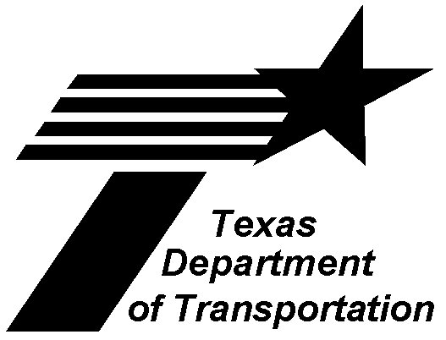

Public Transportation Division

Revised March 2003

Table of Contents
Contents:
Overview 1
Maintenance Plan 2
Introduction 2
Specific Roles 2
Maintenance Goals and Objectives 3
Preventive Maintenance Inspections and Services 4
Introduction 4
Documentation 4
PM Inspections 4
Identified Defects 5
Work Orders 6
PM Services 6
PM Management by Exception 7
Pre-Trip Inspections 8
State of Texas Safety Inspection 9
Maintenance Training 10
Maintenance Management Information System 12
ADA Accessibility Equipment 14
Introduction 14
Preventive Maintenance Plan 14
Pre-trip Inspections 15
Management of Maintenance Resources 16
Introduction 16
Parts 16
Equipment 16
Facilities 17
Fleet 20
Personnel 21
Warranty Compliance 26
Standards for Subcontractors 27
References and Resources 28
Appendices 29
Appendix A – Road Call Information Sheet 29
Appendix B – Road Call Summary 30
Appendix C – PM Guide and Checklist 31
Appendix D – Transit Bus PM Inspection 32
Appendix E – Preventive Maintenance and Inspection, Vans and Wagons 33
Appendix F – Operator’s Defect Report 34
Appendix G – Pre-Trip Inspection Sheet 35
Appendix H – Vehicle Cleanliness Inspection/Task Sheet 36
Appendix I – Transit Agency Vehicle Maintenance: Weekly Report 37
Appendix J – Bus Maintenance Work Order 38
Appendix K – Equipment Inventory 39
Appendix L – Vehicle Master Record 40
Appendix M – Vehicle Information 41
Appendix N – Facility Inspection Checklist 42
Appendix O – Warranty Claim 43
Appendix P – Warranty Claim Summary 44

Overview
The Federal Transit Administration (FTA) provides grant management guidelines for the states through published circulars. Guidelines and management procedures for Metropolitan Planning grants, Capital Program grants and Urbanized Area Formula grants are contained in FTA Circular 5010.1C. Requirements associated with Urbanized Area Formula Program Grants are published in FTA Circular 9030.1C. The Elderly and Persons with Disabilities Program are contained in FTA Circular 9070.1E, and grant management guidelines for Non-Urbanized Areas Program are contained in FTA Circular 9040.1E. These circulars have provided the framework for this vehicle and facility maintenance guide.
The Texas Administrative Code Title 43, Rule 31.53, was adopted to protect the public investment in real property and equipment purchased with state or federal public transportation funds. It grants the Department of Transportation (TxDOT) authority to ensure that subrecipients maintain all property and equipment in good condition.
The purpose of this maintenance management guide is to assist the transit agencies develop a maintenance program that encompasses the maintenance standards listed below. This guide is not intended to be prescriptive or mandatory; however, failure to establish and observe a maintenance program constitutes grounds for TxDOT to direct the transfer or disposition of the vehicle or equipment.
Transit agencies shall have a maintenance program that includes:
- A written maintenance plan;
- Preventive maintenance inspections and scheduled services;
- Provisions for accessible equipment;
- Management of maintenance resources;
- Warranty compliance and recovery; and
- Standards for maintenance subcontractors.
The Public Transportation Coordinator in each Texas Department of Transportation district office has an electronic version of this document if a transit agency wants to copy any material into their management plans.

Maintenance Plan
Introduction
Transit agencies shall have an up to date maintenance plan which outlines the maintenance philosophy of the organization and assigns responsibility for performing maintenance on all vehicles, real property, and equipment in the transit agency. It is designed to keep all vehicles, shop equipment, and tools in safe, reliable, and operational condition. It requires management, trainers, drivers, fuelers, and mechanics to be trained and accountable for specific roles. Good preventive maintenance results from all staff working together as a team.
Specific Roles
Management – Management must be sure that all staff is properly trained in preventive maintenance. The manager must know all parts of the preventive maintenance program, supervise its implementation and evaluate its effectiveness through audits and fiscal control.
Driver Trainers – Trainers must ensure that all drivers understand their role in preventive maintenance. Trainers must make sure that drivers understand and can perform their preventive maintenance roles well.
Drivers – Only the driver sees, hears, and feels the vehicle every day it is driven. Besides being vigilant and reporting observations, the driver must know the proper starting, shifting, and braking procedures to extend the life of the equipment.
Fuelers – They must make sure that all fluid levels are checked each time that the vehicle is fueled. No vehicle should be sent into service low on oil, antifreeze, automatic transmission, or power steering fluid. Unsealed batteries and windshield washer fluid must also be checked and filled. Fuelers must be trained to spot cracked or broken belts, loose or broken brackets, or other worn parts. They should be alert for unusual noises, bad tires, noisy or poor brakes, and clutch adjustments.
Mechanics – Mechanics are the most accountable in the preventive maintenance process. Due to the variety of vehicles, mechanics must be specifically trained for each type of vehicle they might maintain. Upon completing the preventive maintenance, the mechanic signs the PM sheet accounting for the work that has been done.
Maintenance Goals and Objectives
A written maintenance plan should include specific goals and objectives and a means of achieving them. Your overall goal should be to keep your vehicles out of the shop and in service. The goals and objectives of the maintenance program should include or address at a minimum:
- Flexibility for changes in route, schedule, environment, new technology and other impacts;
- Chassis, body, and component manufacturers’ recommended maintenance practices;
- Systematic inspections, services, and repairs performed under local environmental, state, federal, and other regulations that apply;
- Defect reporting;
- A fleet life plan;
- The proper level of fiscal control;
- The proper management of parts, equipment, facilities, fleet, and personnel; and
- A warranty recovery plan.

Preventive Maintenance Inspections and Services
Introduction
Vehicle and component manufacturers prepare manuals that recommend maintenance practices as well as specific guidance and instructions for troubleshooting, removal, overhaul, repair, and replacement of components. These manuals are an important part of the vehicle maintenance plan as they define specific maintenance intervals and provide critical information when the maintenance work is actually being performed.
Preventive maintenance (PM) inspections and services should follow the minimum required by the manufacturer, supplier, or builder. If preventive maintenance services are not being done according to the guidelines of the manufacturer, supplier, or builder, a transit agency may jeopardize any claim to a warranty.
Documentation
Preventive maintenance (PM) inspections and services should be performed, and documented according to a schedule. All documentation should be kept through the life of the vehicle.
Whenever a mechanic or tow truck is dispatched to a vehicle in service, a road call should also be documented. The road call report can be done by the dispatcher or the maintenance technician; by assigning one person to this responsibility, duplication of paperwork can be avoided. Road calls can be classified as chargeable (maintenance item) or non-chargeable (warranty item); or categorized by driver, fault, vehicle, and mechanic. The purpose of monitoring road call reports is to identify failure trends and evaluate the transit agency’s overall maintenance performance.
A road call summary report includes a listing of all vehicles that experienced service interruptions within a given time period. This summary report can help management focus training in areas that need it most or determine problems that need to be resolved.
Samples of a road call information sheet and summary sheet are located in the appendices under Appendix A and Appendix B, respectively.
PM Inspections
PM inspections are scheduled to provide maintenance personnel with an opportunity to detect and repair damage or wear conditions before major repairs are necessary. A common way to conduct PM inspections is to use a checklist where each operation requires a check and a signature for completion. Frequently, the inspection checklist follows a separate procedures manual.
The checklist will:
- Specify each item to be checked;
- Record repairs and the routine application of fluids; and
- Indicate inspection interval (i.e., daily or weekly).
- The inspection procedures manual will:
- Describe the inspection procedures for each item on the checklist;
- Contain a pass/fail standard for each item; and
- Detail actions to correct each problem.
Each procedure within the manual consists of diagrams showing all related components, trouble-shooting and test procedures, and removal and reinstallation instructions. Portions of these checklists and procedures may come from the manufacturer, the vendor, or the transit agency. The manual can be adjusted as experience is gained and used as a training guide for entry-level mechanics.
Examples of PM inspection checklists are located in the appendices as Appendix C.
Identified Defects
Identified defects should be separated and prioritized. Immediately following a preventive maintenance (PM) inspection or notification by a driver, the mechanic must review the discovered defects and sort them into categories. These categories are:
Safety defect - Safety cannot be compromised. The vehicle cannot be released until repairs are completed.
Mechanical defect - A defect that will worsen and increase cost. The vehicle cannot be released until repairs are completed, except for emergencies.
Elective Mechanical Defect - A defect that does not compromise safety, will not cause further damage if operated, but needs to be corrected prior to next PM cycle. (Example: Thin brake linings that can operate another 1,000 miles) If parts are not readily available, the mechanic may calculate a time to reschedule the vehicle into the shop for the brake relining within the 1,000 miles. However, due to transportation costs and disruption to operations, this decision should not be made lightly.
Elective or Cosmetic Defect - The defect will not compromise safety and will not cause further damage or cost as it is an aesthetic defect. This vehicle should be scheduled for an off-peak time in the future, upon delivery of repair parts, as determined by management, or at the next scheduled PM service.
If the fleet experiences recurring defects, the transit agency should check the manufacturers’ recall notices, service bulletins, and campaigns. The maintenance department should inform their procurement department of these defects when considering future vehicle purchases. As a courtesy, the transit agency should also inform the Fleet Manager in the Public Transportation Division of the Texas Department of Transportation.
Sample forms for reporting defects can be found in Appendix D.
Work Orders
Each repair activity should have a step-by-step written procedure associated with it. The work order, also referred to as a repair order, is the backbone of any maintenance performance-monitoring program. Information on all aspects of maintenance performance can be obtained from work orders.
Usually the supervisor initiates the work order by filling in pertinent information such as vehicle number, date, mechanic’s name or identification number, and work to be performed. This provides the assigned mechanic with valuable background information to help identify recurring or related failures.
Mechanics complete relevant remaining sections of the work order, including start and stop times for each segment of the repair, all parts and fluids used, any work deferred, and other items important to the vehicle’s repair history.
These written work procedures can be used as a starting point for correcting faulty workmanship and excessive use of time.
A sample of a detailed work order can be found in the Appendix J.
PM Services
Using the manufacturer’s recommended service schedule as a minimum, PM services can also be scheduled on a time guideline due to the possibility of broken odometers. Many transit agencies will group PM services into different levels, the most commonly used are A, B, C, and D. Level A comprises the most basic and frequent level of PM services while level D consists of more complicated services performed less frequently.
Level A – Conducted at 3,000-mile intervals. Change oil and filter, inspect tires, electrical system, service all fluid levels, lubricate chassis and doors, check A/C, hoses, fire extinguishers, belts, brakes, lights, test drive, body damage, etc. Take oil samples and send to the lab.
Level B – Conducted at 12,000-mile intervals. Includes all items in level A, plus transmission fluid and filter change. Check coolant, specific gravity, and pH.
Level C – Conducted at 24,000-mile intervals. All items in levels A and B, plus change fuel filter, perform complete engine tune-up, test engine compression, replace air filter, drain and refill differential lubricant.
Level D – Conducted at 48,000-mile intervals. All items in levels A, B, and C, plus inspection and repack of wheel bearings, and extensive inspection of braking system.

Preventive Maintenance Levels
PM Level | Cumulative Mileage | PM Description
A | 3,000
A | 6,000
A | 9,000
B | 12,000 | A + B
A | 15,000
A | 18,000
A | 21,000
C | 24,000 | A + B + C
A | 27,000
A | 30,000
A | 33,000
B | 36,000 | A + B
A | 39,000
A | 42,000
A | 45,000
D | 48,000 | A + B + C + D
Repeat the schedule
PM levels are scheduled based on projected mileage, estimated time for completion, and level of effort and expertise. As each level of PM service requires more time to complete, PM levels should be assigned in such a manner as to provide a balanced workload for the shop.
Example: A vehicle operates an average of 100 miles per day for five days per week. At 500 miles/week, the vehicle would accumulate 3,000 miles in 6 weeks. This would set the PM service intervals at every six weeks, every sixth Monday. Another similar vehicle with the same mileage conditions may be scheduled every sixth Tuesday, or every sixth Friday, as the schedule dictates.
In this manner, the time consumption and labor efforts for PM levels have been established. This permits management to assign shop work schedules and resources in an orderly and cost effective fashion. All PM inspections and services should be consistent with the available daily manpower.
Samples of PM scheduled services are located in Appendix D and Appendix E.
PM Management by Exception
There are many good reasons for varying a scheduled PM service. It may not hurt the vehicle to have the PM service performed off schedule and the transit agency can manage its PM program to achieve its overall goals.
Management by exception allows flexibility in the PM program by authorizing the mechanic to make decisions on deleting or adjusting certain items listed on the PM schedule.
Examples:
Vehicle XXX comes in for a level D service. The mechanic checks the vehicle’s record and finds that the front wheel bearings were inspected and repacked at the time of the last front brake job, only 1300 miles ago. He could then delete the requirement to repeat this service.
Vehicle ZZZ comes in for a level B service. But, the vehicle history shows the vehicle only operated 190 miles since its last level A inspection, and has spent the last several weeks in a local shop for body damage repair. The mechanic may then elect to delete portions of the current level B service, substitute a very rigid inspection of damage related repair items, service all fluid levels, check all safety items, and test drive. He may then wish to change the next scheduled service from a level A to a level B.
Pre-Trip Inspections
An important part of preventive maintenance is the establishment of strong communication ties between drivers, mechanics, and management. An easy way to ensure and document this communication link is by way of the driver’s daily vehicle inspection checklist.
Each vehicle should have blank copies of the checklist on-board for the drivers to conduct the inspection. The driver should identify any defects and report them to maintenance before driving the vehicle. If a problem arises during the shift, the driver should add comments to the checklist. All checklists are to be maintained in the vehicle’s permanent file.
NOTE: When malfunctions and/or defects are detected which threaten safe operating performance, the vehicle will not be used to transport persons until defects are corrected.
The pre- and post-trip inspection forms shall be legibly completed and signed by the vehicle driver. Pre-trip inspections should include as a minimum:
- Cleanliness - Properly maintained and free of loose articles.
- Lights and reflectors - High/low beams, tail lights, turn signals, 4-way hazard flashers, marker lights, license plate light and reflectors should be cleaned as needed.
- Brakes - Both foot and emergency brakes should be capable of effectively stopping or restraining the vehicle. Brake pedal should be firm after 1-2 inch free-play on a single down stroke. No noises, vibration or steering changes should result from applying the brakes while moving.
- Horn - Gives an adequate and reliable warning signal.
- Windshield, washer, wipers and defroster - Surfaces must be clean and unobstructed, inside and outside. Washer reservoirs are to be filled as needed.
- Mirrors - All rear vision mirrors must be clean, properly adjusted and unobstructed. Outside mirrors must be mounted on both sides.
- Tires - Must be of adequate load capacity when vehicle is fully loaded. Tires shall be inflated to recommended pressures and compatible with each set (i.e., all radials or all bias ply; no mixed sets). Tire wear surfaces and sidewalls shall be inspected daily for debris, damage and wear. Tires shall be replaced prior to revealing the “wear bars” between the treads at the contact surface.
- Speedometer - Shall be operational and accurately record speed.
- Seat Belts - In good operating condition and used by all passengers and drivers. Wheelchair passenger restraint and securement systems shall be fully operational.
- Doors - Capable of being opened, shut and locked as required.
- Fluids - All fluid levels must be checked each time the vehicle is fueled and maintained at the manufacturers recommended operating levels. This includes engine coolant, oil, battery electrolyte, brake fluid, power steering fluid, transmission fluid and washer solvent.
- Wheelchair lifts - Check operating and structural condition by operating through one complete cycle.
- Emergency equipment - Should be present and operational:
  - Flares
  - Fire extinguisher
  - First aid kit
  - Spare tire
  - Jack and lug wrench
  - Reflective triangles
  - Flashlight with batteries
  - Blood borne pathogens clean up kit
  - Reflective vest for driver
  - Clean up kit for cleaning and sanitizing the vehicle
Examples of different inspection forms can be found in Appendix F, Appendix G, Appendix H, and Appendix I.
State of Texas Safety Inspection
All vehicles must display a Texas Safety Inspection Certificate, which is good for 12 consecutive months. These certificates can be obtained at a state-approved safety inspection station or an in-house safety inspection station.
All buses, with the exception of school buses, will be inspected for evidence of financial responsibility and the following:
- Horn
- Windshield wipers
- Mirror
- Steering
- Seat belts (driver only)
- Brake systems and parking
- Tires
- Wheel assembly
- Exhaust system
- Exhaust emission system
- Beam indicator
- Tail lamps (2)
- Stop lamps (2)
- License plate lamp (1)
- Rear red reflectors (2)
- Turn signal lamps
- Clearance lamps
- Side marker lamps
- Side reflectors
- Head lamps (2)
- Motor, serial, or vehicle identification number
You can view each item and the inspection rejection criteria at: http://www.txdps.state.tx.us/vi/inspection/item_class.asp.
If your fleet contains commercial motor vehicles, you can view the rules and regulations for inspected items at: http://www.txdps.state.tx.us/vi/publications/rules/rules.html.
The best time to perform this safety inspection is after the mechanic has completed a scheduled PM inspection and repair. This will help assure that there will be no problems that could cause rejection.
Maintenance Training
Maintenance training for vehicle mechanics should include as a minimum:
- Training on the equipment for which they have responsibility;
- Vehicle maintenance program scope and objectives ;
- Transit agency’s policies, including management’s policy and attitude towards safety;
- Applicable rules and regulations and how they are enforced;
- Forms and procedures used by the maintenance department, their purpose and how to complete them;
- The role of safety when performing normal tasks and during emergencies;
- Shop and overall facility familiarization;
- Instruction on the safe operation and maintenance of on-board safety equipment, to include:
- Doors, door interlocks and brakes
- Kneeling system
- Wheelchair lift
- Brake system
- Climate control systems (heater and air conditioner)
- Electrical systems
- Engine and drive system
- Horn, interior and exterior lights and wipers
- Steering and suspension systems
- ADA equipment, including tiedowns and wheelchair locking devices
- Personal protective equipment;
- Welding equipment and protective measures to be taken during welding operations;
- Road call procedures;
- Use of shop equipment, such as air, jacks, lifts and cranes;
- Refueling procedures;
- Hazardous communication; and
- Communications systems, radio, automatic vehicle locator, and security system.
Maintenance training should cover all vehicles and equipment operated by the transit agency. Training manuals, maintenance manuals and all updates/revisions should be provided for each type of vehicle and equipment being used by the transit agency.
Vehicle manufacturers or component companies that manufacture the engine, transmission, or heating and air conditioning for the vehicle often offer maintenance training. Their expertise should be requested whenever new equipment is brought on-board or a vehicle is retrofitted with their equipment. In addition to in-house training, these manufacturers will often provide regularly updated manuals and bulletins to keep the mechanics informed of the latest recommendations and guidelines.
Only qualified drivers should maneuver vehicles within the maintenance facility and garage. Backing should be prohibited unless absolutely necessary. When backing is necessary, it should only be done with a spotter or a guide.
All drivers should be given a complete familiarization of the vehicle including engine compartment, driver controls and passenger safety devices. Drivers should be trained to recognize unusual noises and communicate basic mechanical problems with the maintenance department.
Facility safety training should include additional information on the following:
- Fire safety training, the proper use of all fire/life safety equipment
- Location of shop power emergency disconnect
- First aid
- Shop layout and egress routes
- Hazard communication
New mechanics should receive safety training and be assigned to a senior mechanic for a certain period of time prior to performing their job. Beyond this initial orientation and training, mechanics should be continuously trained to ensure that their skills are kept up-to-date.
All training should be documented and the effectiveness of the training program evaluated periodically.
Maintenance Management Information System
A Maintenance Management Information System (MMIS) is essential for the scheduling of maintenance activities and controlling labor and material costs. MMIS software does not replace effective maintenance program management. Rather, it serves as a tool to make that program faster and more efficient. Proper use of the software provides management with the ability to evaluate the effects of changes in maintenance procedures and policies.
Transit agencies can obtain a MMIS on the Internet, from a specialized vendor, or rely on standard business software. A MMIS should be able to perform the following functions and generate accompanying reports:
- Determine vehicle status, including the tracking of mileage and fuel purchases;
- Generate and track work orders;
- Track and schedule PM inspections and services;
- Track services performed externally;
- Labor details;
- Vehicle licensing information;
- Update vehicle history files;
- Assign costs to various cost centers;
- Update parts inventory;
- Issue purchase orders;
- Track driver information;
- Retain insurance data;
- Document roadcalls;
- Maintain a list of vendors; and
- Document warranty recovery.
An example of a maintenance status report from a MMIS follows:
At any time, you can view the current status of the PM services defined for a vehicle.
This function will allow you to see what PM services are currently in need of attention and the status of the other maintenance operations that are not in need of attention. To report ONLY the maintenance due, use the PM Check Wizard instead.
To view the Current Maintenance Status:
1) Select a vehicle on the Fleet Manager screen.
2) Click the button on the Fleet Manager screen.
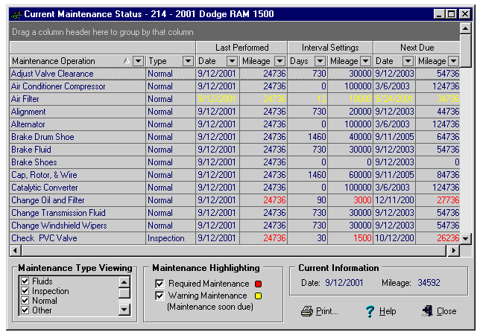
3) The Current Maintenance Status screen displays a list of PM services that details the following for each:
- Date and mi/km/hr that the service was last addressed.
- Desired interval at which the service should be addressed.
- The calculated date and odometer reading at which the service will be due.
4) You can easily see what is currently due by the RED color coded interval data. The YELLOW interval data is what will soon be due (less than 15 days, or 250 mi/km/hr). These parameters can be changed on the Configure Fleet Maintenance Pro screen. BLUE simply indicates the service is not currently due.

ADA Accessibility Equipment
Introduction
Title 49 CFR Section 37.161 Subpart G requires that transportation services maintain the ADA features of their facilities and vehicles in operative condition. These ADA features include, but are not limited to:
- lifts and other means of access to vehicles;
- securement devices;
- elevators; and
- signage or systems to aid communications with persons who have impaired vision or hearing.
Accessibility features must be repaired promptly if they are damaged or out of order. When an accessibility feature is out of order, the transit agency shall take reasonable steps to accommodate persons with disabilities who would otherwise use the feature.
49 CFR Section 37.163 requires the transit agency to establish a system of regular and frequent maintenance checks of the lifts. The vehicle drivers must report, by the most immediate means available, any failure of a lift. If there is no available spare vehicle to take the place of a vehicle with an inoperable lift, the transit agency may keep the vehicle in service for no more than five days (if the transit agency serves an area of 50,000 or less population) or three days (if the transit agency serves an area of over 50,000 population) from the day of discovery.
Preventive Maintenance Plan
A preventive maintenance plan for ADA accessibility features should be in place; including a system of maintenance checks based on manufacturers recommended guidelines. The ADA elements may be incorporated in the regular maintenance plan or they may be addressed separately, so long as the transit agency can demonstrate that accessibility features are maintained and operational.
Perform lift maintenance at scheduled intervals according to the minimum requirements by the manufacturer. Correct any potentially dangerous situations at once. Wheelchair lifts should be fully deployed and exercised with weight to simulate a 600 pound operating condition.
Pre-trip Inspections
Wheelchair lifts should be fully deployed and exercised as part of the daily pre-trip inspection. All drivers who operate a vehicle with a mechanical lift should be instructed on the importance of proper cycling. Experience has shown that frequent exercising of wheelchair lifts accomplishes two objectives:
- Malfunctioning lifts are identified quicker, often before malfunction results in difficulties for a wheelchair passenger; and
- The regular exercising of the lift mechanism helps prevent maintenance problems and failures due to build-up of dirt, foreign objects, or corrosion.
Instructions for normal and emergency operations of the lift or ramp should be carried or displayed in every accessible vehicle.

Management of Maintenance Resources
Introduction
Each transit agency should have a plan for the safe and proper management of maintenance resources; including parts, equipment, facilities, fleet, and personnel.
Parts
By keeping a replacement part on hand for every vehicle component, a transit agency would be able to minimize vehicle downtime. However, this would be an expensive practice. Besides the cost of buying a part that is not immediately needed, there are storage and warehousing costs, and a potential future cost if a part becomes obsolete.
Obviously, a more balanced approach is required. All replacement parts should be identified by the frequency of part failures, especially when part failures lead to road calls. If a transit agency can develop accurate parts statistics, it has an opportunity to benefit from cost controls by knowing where a part should be stored. For instance, a part with high failure frequency should be very accessible to the technicians:
Location of Inventory
Part Failure Rate | Part Source
High | In-stock
Medium | Local vendor
Low | Remote vendor
Many parts retain a core value even though the part is broken. Suppliers may apply a credit or discount to the customer when the part is replaced if the customer returns the old part. In cases where a transit agency has many vehicles of the same type, it is advisable to keep a few core parts on hand. In addition, consider keeping enough core parts on hand for the remaining service life of a vehicle in cases where a part is becoming obsolete.
Equipment
Machines, Tools and Equipment
Preventive maintenance and proper care of machinery, equipment and tools is essential. Equipment and tools in disrepair pose unnecessary hazards. It is important to place them in their proper designated storage place after use.
Jack Stands
Jack stands should be used whenever the wheels are raised two inches or more off the ground. The vehicle must be lowered onto the jack stands and not suspended over them.
Floor Jacks/Lifting Devices
Care should be taken in instructing all shop personnel on the proper use and positioning of floor jacks and other lifting devices. Lift points should be marked on vehicles.
Equipment Guards
Guards should be installed and used on all equipment with belts or pulleys.
Tire Cages/Inflation Devices
Instructions for mounting/dismounting tires should be posted and strictly followed. Cages or safety inflation devices should be used any time tires are being inflated.
Tools
Tools should be kept clean of grease and oil. The tool should be properly selected for the job with the appropriate hand position and technique used for the employee’s protection. Tools should be inspected regularly for defective conditions.
Cords/Hoses
Air hoses, extension cords, and droplights should be inspected regularly for worn or frayed condition. They should be kept in a stored or hanging position when not in use. They should be wiped clean after each use. All cords and electrical equipment should have a grounded plug.
Eyewash Stations
An eyewash station should be provided and located near a water supply.
Fire Extinguishers/First Aid Kit
At a minimum, one fire extinguisher should be available on each shop wall. A first aid kit should be displayed in the shop with easy access for shop employees. Both items should be inspected on a regular basis (first aid kit supplies, fire extinguisher charge and condition). Both items should be labeled indicating their permanent location.
Other Shop Equipment
All shop equipment should be inspected regularly for their condition and cleanliness. Broken or worn equipment (ladders, hoses, stools) should be replaced to eliminate the possibility of injury to an employee.
Facilities
Safety is the most important concern in managing a maintenance facility. Safety must be practiced at all times, and required by management. It is the responsibility of management to ensure that safe practices are in place at all times, and to conduct regular and documented safety meetings. All safety posters and reminders should be posted in the shop. OSHA rules and regulations provide excellent guidance on facility maintenance practices. Sample facility inspection sheets can be found in Appendix N.
Housekeeping
A key ingredient to a safe work environment is good housekeeping. Besides providing a pleasant environment that will improve morale and productivity, good housekeeping helps prevent accidents caused by spills of materials and tools that are carelessly left around. Shops and service areas that are kept neat and clean often require fewer repairs and replacement of expensive items.
Employees should be responsible for cleaning up their spills. All spills should be mopped or cleaned up quickly. Floors and aisles should be swept on a daily basis. Workbenches and other designated work surfaces should be kept free of clutter and cleaned daily. Adequate trash containers should be provided in the shop area and on the fuel island(s). The containers should be emptied daily. The facility lot and fuel island should be kept clean of trash and debris.
Materials and equipment should be stored in designated storage areas that are well maintained and free of clutter. Makeshift sites tend to become cluttered quickly, hampering employee mobility, and adding to the chance of accidents and injury.
Inspect storage racks, shelves and storage equipment regularly for safety and strength. Platforms, stairwells, and walkways should be well maintained to eliminate clutter and spills. Stairwells often become temporary storage areas making them hazardous for all personnel.
A well-kept shop is an essential part of an effective disaster and fire safety program. Dirty, cluttered aisles and floor space prevent a quick exit in the event of an emergency and increases the chance of fire and death.
Shop Access
Access to the shops should be restricted to shop personnel and management only. Signs should be displayed to indicate that it is a restricted area.
No Smoking
Smoking should be prohibited in all shops. Signs should be posted.
Emergency Numbers
Emergency phone numbers should be posted near the shop phone(s).
Emergency Exits
Signs should be posted indicating emergency exits.
Fuel Island
The fuel island should be inspected on a regular basis for defective or worn hoses and nozzles. A fire extinguisher should be kept on the fuel island at all times. At a minimum, the extinguisher should meet class “B” standards (appropriate for use on flammable liquids and gases). However, it is strongly recommended that a class “ABC” extinguisher be used because it can handle a wider variety of fires that might occur. Class “ABC” fire extinguishers are approved for use with ordinary combustibles (i.e. wood, rubber, plastics, etc.), flammable liquids and gasses, and electrical equipment.
Exhaust Hoses
Hoses should be used when vehicles are running and garage doors are closed. Hoses should be inspected for wear or damage.
Glass
Care should be taken when handling or disposing of glass in the shop. Gloves should be worn when glass is being handled.
Siphoning
Siphoning by mouth is prohibited. Proper pumps should be used to extract gas or other fluids from tanks, barrels, or containers.
Flammables
Proper procedures for handling, storing, and disposing of flammables should be explained to shop employee.
Batteries/Acid
Protective clothing including aprons, gloves, and safety glasses must be worn when filling batteries. The proper storage, handling, and disposal of all batteries is mandatory. Check local and state requirements for disposal.
Jump Start Procedures
Employees should be properly instructed on jump starting procedures, including cable connection and disconnection.
Overhead Clearance
Exhibit caution to avoid striking your head on vehicle mirrors or other projections in and around the shop.
Overhead Doors
Overhead doors should be kept either all the way up or all the way down. Doors should not be left in a partially open or closed position.
Sharp Instruments
Razor blades and other sharp cutting objects should be stored properly in a designated drawer or cabinet. Razor blade holders should be used.
Vehicle Movement
When vehicles are being moved for any reason, including fueling, speed restrictions should be followed. Speed limits should be posted in the shop and throughout the yard. Shop personnel should ask for assistance when backing a vehicle, wear seat belts, and drive with the service door closed. If anyone, including shop or other personnel is on-board, they should be properly seated and not standing in the step well area.
Entry/Exit From Vehicles
Shop personnel should not vault or jump into or out of a vehicle.
Fleet
Physical Inventory
Transit agencies should conduct a physical inventory of equipment and reconcile the results with the equipment records every year. A control system must be developed to prevent loss, damage, or theft of property. Typically a property control number, a serial number, or the vehicle identification number identifies the equipment. Any loss, damage, or theft must be investigated and documented by the transit agency. An example of an inventory sheet is found in Appendix K.
Vehicle history file
Each vehicle should have a written record documenting preventive maintenance, regular maintenance, inspections, lubrication and repairs performed. This record can be duplicated for the service center where the vehicle is based.
Such information is useful for PM services as the part can be ordered and in hand before the vehicle comes in for a scheduled maintenance. As well, parts for road calls can be dispatched with the service truck, saving time and money. A vehicle’s history is also valuable in locating persistent problems and may serve to determine if individual driver habits merit particular attention. Sample forms are provided in Appendix L and Appendix M.
Such records shall be maintained for the life of the vehicle and include at a minimum the following information:
- Identification of the vehicle, including make, model, license number or other means of positive identification and ownership;
- Date, mileage, and description of each inspection, maintenance, repair or lubrication performed;
- If not owned by the transit agency, the name of the person or company furnishing service with this vehicle; and
- The name and address of any business firm performing an inspection, maintenance, lubrication or repair.
Fleet life plan
A fleet plan is an internal, working document that can be updated whenever conditions warrant or at least annually. This document should cover five (5) calendar years. The fleet plan addresses replacement and expansion without regard to funding availability. The fleet plan should be based on service needs and economic replacement life. It is used to project new equipment deliveries and disposal, and helps to plan grant activities. It keeps track of spare ratios and can help predict when to augment or reduce parts levels. It helps the transit manager consider vehicle rehabilitation or replacement in lieu of extensive repair and constant unscheduled maintenance.
Contingency fleet plan
Vehicle failures can cause “spikes” in workloads, an increase in operating costs, and potentially interrupt transit service. Transit managers must find a way to skew the schedule of identified services and reduce the impact of failure cycles.
Transit agencies with a contingency fleet of spare vehicles are able to continue transit service while vehicles are in the maintenance cycle. Transit vehicles held in a contingency fleet must be properly stored, maintained, and documented in a contingency plan and updated as necessary.
For fleets with fewer than 50 fixed-route vehicles, and for paratransit fleets, judgment must be applied to determine what is an excessive number of spare vehicles. For fleets with 50 or more fixed route buses, the spare ratio should normally not exceed 20 percent of the vehicles operated in maximum service. Maximum service means the number of revenue vehicles during the peak season of the year; on the week and day that maximum service is provided. It excludes atypical days and one-time special events.
To calculate the spare ratio, divide the number of spare vehicles by the peak requirement (the number of vehicles operated in maximum service). The number of spare vehicles is the difference between the total fleet and the peak requirement.
Transit vehicles may also be stockpiled in an inactive contingency fleet in preparation for emergencies. However, no transit vehicle may be stockpiled before it has reached the end of its service life.
Retrofitting of vehicles
Retrofitting a vehicle with a wheelchair lift or ramp shall not exceed the manufacturer’s gross vehicle weight rating, gross axle weight rating, or tire rating on the accessible bus. The installation of the wheelchair lift or ramp, its controls, and the method of attachment shall not diminish the structural integrity of the accessible vehicle or cause a hazardous imbalance.
No part of the lift or ramp, when installed and stowed, shall extend laterally beyond the normal side contour of the vehicle nor vertically beyond the lowest part of the rim of the wheel closest to the lift. Each wheelchair lift or ramp assembly shall be legibly and permanently marked with the manufacturer’s name, address, and the month and year of manufacture.
NOTE: No vehicle alterations shall lower the road clearance of the vehicle below the manufacturer’s clearance standards.
Personnel
Personnel Safety
The health and well being of every employee is of vital importance. The active participation of each employee is mandatory in establishing a safe work environment. The company should keep the employees aware of required safety and health procedures and the employees should be expected to comply with the prescribed guidelines and procedures.
Personnel Protective Equipment
Employees are required to wear all protective equipment at the proper times and in the proper environments. Failure to wear the required protective equipment should be cause for disciplinary action.
Tool Use/Technique
If the employee is unsure about the proper use of a tool or proper technique, he/she should ask for assistance before using or continuing.
Eye Protection
Eye protection should be worn at all times when under a vehicle, using grinders, buffers, cutting equipment, lathes, and other related tools.
Hearing Protection
Employers shall make hearing protectors available to all employees exposed to an 8-hour time-weighted average of 85 decibels or greater at no cost to the employees. Hearing protectors shall be replaced as necessary. Employees shall be given the opportunity to select their hearing protectors from a variety of suitable protectors provided by the employer.
Hand Protection
Gloves should be worn to protect an employee while handling chemicals, using razor blades, and when welding or cutting. The gloves should extend over the forearms to protect against sparks or chemical splash.
Welding Hood
A welding hood should be worn at all times when welding. Welding goggles should be worn when using cutting torches.
Footwear
Soft-soled shoes are prohibited. A shoe with steel or reinforced toe and a nonskid sole is highly recommended.
Respirators
The company should furnish respirators and require that all mechanics wear them when exposed to lead, volatile organic compounds, or any EPA listed airborne hazardous material. An approved respirator or NIOSH/OSHA approved dust mask must be worn while sanding or grinding any painted or primed surfaces. Respirators should be worn by anyone exposed, regardless of their distance from the point where the contamination is generated. Respirators should be inspected prior to use for proper exhaust and inhalation valves, cartridge pre-filter, headband adjustment and the overall condition.
Carbon Monoxide Detectors
Carbon monoxide is a colorless, odorless, tasteless and toxic gas produced as a by-product of the combustion in vehicles. It is aggravated by limiting the amount of fresh air flowing into the shop and can cause headaches, dizziness and nausea in employees. Employers should install a carbon monoxide detector that conforms to minimum sensitivity and alarm characteristics as defined by Underwriters Laboratory in UL 2034.
Horseplay
Horseplay is prohibited. Serious accidents and injuries can occur as a result of practical jokes and thoughtless pranks played on unsuspecting workers.
Lifting Technique
Use proper lifting techniques at all times when lifting objects. Bend the knees to utilize leg power and get into a proper position before lifting. Ask for assistance from fellow workers for heavy loads. Avoid twisting and awkward/jerky movements during a lift or while carrying an object.
Push/Pull/Torque
Use caution not to overexert when pushing, pulling or using a torque wrench. Watch the hand clearance closely.
Chemical and waste management
The Federal Hazard Communication Standard (29 CFR Section 1910.1200) is also known as the “Right to Know” law. This standard gives employees a right to know about the hazardous chemicals used in their workplace and is designed to reduce the incidence of chemically related injuries and illness. Employers must develop a written hazard communication program for the workplace, maintain lists of present hazardous chemicals, label all containers of chemicals in the workplace, distribute material safety data sheets to employees, store hazardous chemicals in approved locations, and implement employee training programs regarding hazards of chemicals and protective measures.
Most fleet maintenance facilities generate some hazardous wastes and/or other wastes that are regulated by state or federal environmental programs. Hazardous wastes include those chemicals that are specifically “listed” in the EPA regulations (40 CFR 261.31-33) and/or wastes that exhibit any of the four hazardous characteristics:
- Corrosivity - a pH less than or equal to 2 or greater than or equal to 12. 5. Strongly acidic/alkaline.
- Reactivity - chemically unstable, may react violently with air, water, other chemicals, or wastes that release any cyanide or sulfide. Not commonly encountered at vehicle maintenance facilities.
- Ignitability - liquid with a flash point of less than 140 degrees F. Spent solvents and paint wastes are sometimes hazardous due to ignitability.
- Toxicity - a list of 40 chemicals (heavy metals, pesticides, and organics) specified by EPA. The lab test used to determine toxicity is called the Toxicity Characteristic Leachate Procedure (TCLP). Trichloroethylene, benzene, and lead often make a waste hazardous based on the TCLP.
Spent solvents from parts cleaning operations are an example of a waste generated from vehicle maintenance facilities that often require hazardous management due to ignitability, toxicity, or listing. Some other wastes may or may not meet the definition of hazardous waste but do require special handling. The following provides general guidance for management of some of the more common waste streams:
Waste vehicle lubricants - While generally not a hazardous waste, petroleum-based fluids must still be carefully managed. If kept in clean storage, authorized recyclers (registered with Texas Commission on Environmental Quality) can usually accept used oil and other lubricants, at little or no cost.
Spent batteries - These are commonly recycled, which can be made a condition of the purchase contract. They should be stored in a manner that prevents releases to the environment. Batteries with damaged cases should be containerized to prevent releases. Old batteries should be recycled or disposed within one year of generation.
Scrap tires - Not classified as hazardous waste, but generally are not accepted by landfills unless split, quartered, or shredded. Tire recycling or disposal companies are available to collect used tires for a fee in most areas.
Used oil filters - Should be punctured and thoroughly drained to remove liquids. The recovered oil and filter are recycled separately. Containers used to store filters should be clearly labeled.
Spent solvents - Solvent recycling programs are available in most areas and can reduce the liability associated with disposal. The use of non-ignitable (low flash) solvents for washing parts may result in a non-hazardous waste stream.
Used antifreeze - Draining into the sanitary sewer is generally prohibited by local sewer and pretreatment ordinances. Authorized recyclers can usually pick up used antifreeze. Recycling equipment is available for purchase, but some equipment may not remove all impurities.
Refrigerant - Air conditioning refrigerants must be recycled. Technicians servicing these systems should be certified by an EPA approved training program.
Paint wastes and thinners - Must be sent to an authorized treatment, storage, disposal or recycling facility. Frequently, the companies that service and recycle cleaning solvent can set up a waste stream to pick up paint wastes as well.
Discharge to sanitary sewers - Any discharges, such as vehicle wash water, should comply with municipal discharge ordinances and/or industrial sewage discharge agreements. The discharge of wash bay wastewater to septic systems should be avoided unless the appropriate state or county permits can be obtained.
The Occupational Safety and Health Administration’s (OSHA) Hazard Communication Standard, and the Texas Hazard Communication Act are designed to ensure that employers and employees are aware of all chemical hazards in the work place. The Material Safety Data Sheet (MSDS) is the primary source of information on all chemicals used in the workplace. Each time a new product is procured the MSDS should be obtained from the supplier, and placed in a designated location readily accessible to employees. The MSDS contains the physical and chemical characteristics and health hazards associated with the product, as well as handling precautions and emergency procedures.
A product’s MSDS should be evaluated prior to purchasing or accepting trial samples of a product. This information can be useful in determining if acceptance of the product poses additional safety concerns or if unused residuals will require disposal as hazardous waste.
Employers shall provide employees with effective information and training on hazardous chemicals in their work area at the time of their initial assignment, and whenever a new physical or health hazard the employees have not previously been trained about is introduced into their work area. Information and training may be designed to cover categories of hazards (e.g., flammability, carcinogenicity) or specific chemicals. Chemical-specific information must always be available through labels and material safety data sheets.
Employees shall be informed of any operations in their work area where hazardous chemicals are present, the location and availability of the written hazard communication program, including the required list(s) of hazardous chemicals, and the material safety data sheets. Employee training shall include at least:
- The methods and observations used to detect the presence or release of a hazardous chemical in the work area (such as monitoring conducted by the employer, continuous monitoring devices, visual appearance or odor of hazardous chemicals when being released, etc.).
- The physical and health hazards of the chemicals in the work area, including signs and symptoms of exposure to chemicals and any medical condition known to be aggravated by exposure to the chemical.
- The measures employees can take to protect themselves from these hazards, including specific procedures the employer has implemented to protect employees from exposure to hazardous chemicals, such as appropriate work practices, emergency procedures, and personal protective equipment to be used.
- An explanation of the labeling system and the material safety data sheet, and how employees can obtain and use the appropriate hazard information.

Warranty Compliance
A warranty is an assurance from a manufacturer that a product will perform properly for a specified time or usage level. Warranties cover new vehicles, new or replacement parts, and most vendor’s work. If the product fails to meet this assurance, the manufacturer is obligated to make restitution. Restitution may be replacement or repair of the defective product, or reimbursement to the owner for the cost of the repair or replacement. Warranties may be formal written policies or implied warranties.
Warranty claims should be pursued effectively and promptly. The warranty of vehicles, physical plant, and equipment often is valid only if a transit agency adheres to the manufacturer’s recommended maintenance program. A warranty recovery system, warranty records, and annual summaries of warranty claims submitted and received should all be maintained by the transit agency. Several sample forms can be found in the appendices of this manual. Appendix O is the Warranty Claim and Appendix P is the Warranty Claim Summary.
A warranty program is also an opportunity to provide feedback to manufacturers regarding their product. Most manufacturers rely heavily on this information when considering product improvements. Some improvements can result in field corrections (recall notices and campaigns).
Prior to performing repairs and seeking restitution, the transit agency should request approval to perform warranty repairs from the vendor or the manufacturer. To facilitate the process of identifying warranty items, a review of the individual vehicle’s history file should be conducted.
Whenever possible, include a copy of the repair order with the warranty claim form. Documentation should include the date and vehicle mileage at time of failure, vehicle identification number, description of work performed, and costs incurred. Make sure the part can be matched with the warranty claim.
It is helpful to know the following about your warranties:
- Compensation others are receiving – use this knowledge as leverage in bargaining;
- The reimbursable labor rate (flat rate or actual time and materials) - it should include a percentage for overhead; and
- If they only cover failed parts, or if modifications to correct the problem will also be covered.
Some reasons that transit agencies don’t receive maximum benefit from a warranty program:
- Warranty coverage is not understood, and therefore, never filed;
- Repair work is performed before it is determined that the failure was warranty related;
- Information for the warranty claim is lost;
- Failed part cannot be matched to the warranty claim;
- Warranty claim not submitted on time; and
- Apathy or “too much paperwork.”

Standards for Subcontractors
When equipment is maintained under contract to a service contractor, the transit agency should require a written maintenance plan that can be monitored. Contract language should include requirements for maintenance, an annual physical inventory, a warranty recovery program, and other control measures.
Maintenance requirements of the subcontractor should include at a minimum:
- A written preventive maintenance program to be developed and implemented with an appropriate preventive maintenance philosophy.
- All vehicles to be maintained according to chassis, body and component manufacturers recommended practices.
- Systematic inspections, services, and repairs under local, state and other regulations that apply.
- Assurance that all vehicles will provide a high threshold of safety and reliability for the passengers.
- Vehicles are clean and inviting to passengers.
- Spare vehicles are part of the process of regular preventive maintenance.
- The preventive maintenance program is flexible enough to respond to changes in route, schedule, environmental, and other impacts.
- Operation at the proper level of fiscal control.
- Lines of communication will be open and fleet issues will be discussed.
The transit agency should also expect the maintenance subcontractor to use due diligence when performing and/or reporting cost center elements.
Contracts for service and maintenance reports from contractors should be kept on file at the transit agency’s office. The transit agency should conduct periodic inspections and audits on the maintenance subcontractor. Corrective actions should be required on all deficiencies and defects identified in the inspections and audits.

References and Resources
American Public Transportation Association: Manual for the Development of Bus Transit System Safety Program Plans
Capital Area Rural Transportation System (CARTS), Austin, TX
Capital Metropolitan Transportation Authority (Capital Metro), Austin, TX
City Transit Management Co., Inc. (Citibus), Lubbock, TX
Colorado Valley Transit District (Colorado Valley Transit), Columbus, TX
Community Transportation Association of America: Vehicle Maintenance Management & Inspection
Federal Transit Administration: Bus and Passenger Accident Prevention
Florida Department of Transportation: Bus Transit System Safety Program
Halsey King and Associates, Inc., Carlsbad, CA
Heart of Texas Council of Governments, Heart of Texas Rural Transit District, Waco, TX
New York State Public Transportation Safety Board, Bus Safety Section
System Safety Program Plan Guidelines
Ohio Department of Transportation, Office of Public Transportation
Model Vehicle Safety Program
Public Transit Services, Mineral Wells, TX
Rural Technical Assistance Program: Introduction to Prevention Maintenance: An Investment that Pays Off
Texas Department of Transportation, Corpus Christi District Office
Texas Department of Transportation, General Services Division, Fleet Management, Austin, TX
Texas Department of Transportation, Public Transportation Division
Public Transportation Maintenance Management Guide, 1998
The Hop-Rural Public Transportation, Hill Country Transit District, San Saba, TX
Transportation Research Board: Bus Occupant Safety
Transit Cooperative Research Program, TCRP Synthesis 18
Transportation Research Board: Monitoring Bus Maintenance Performance
Transit Cooperative Research Program TCRP Synthesis 22
Wisconsin Department of Transportation: Bus Safety Manual

Appendices

Appendix A – Road Call Information Sheet
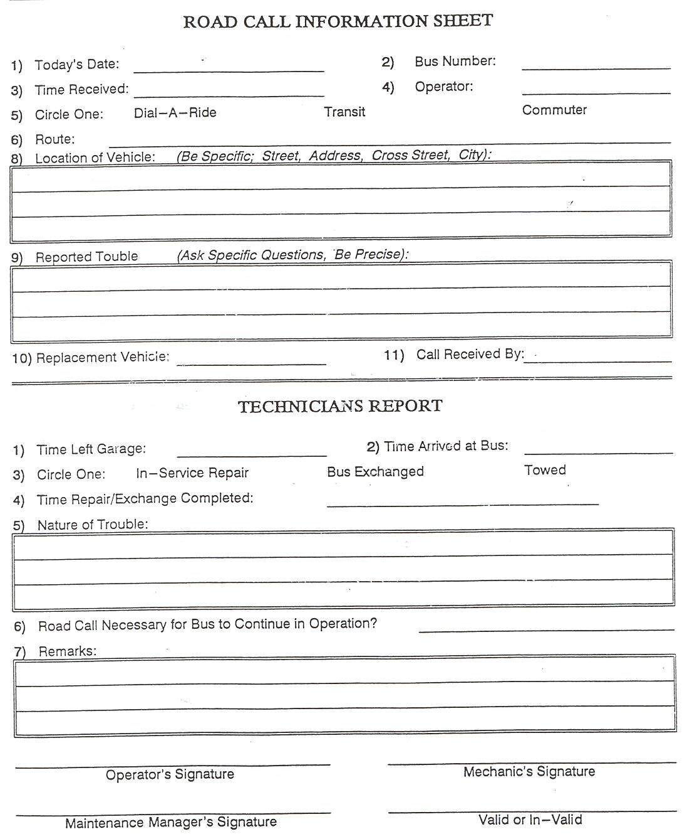

Appendix B – Road Call Summary
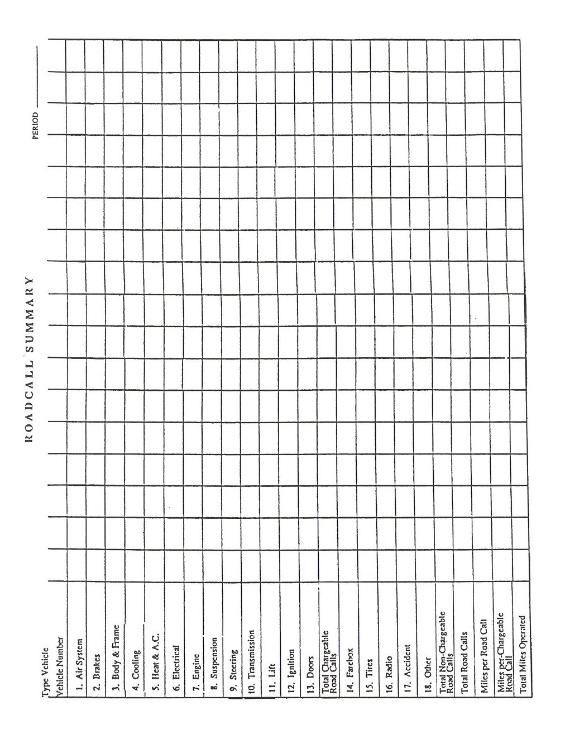

Appendix C – PM Guide and Checklist
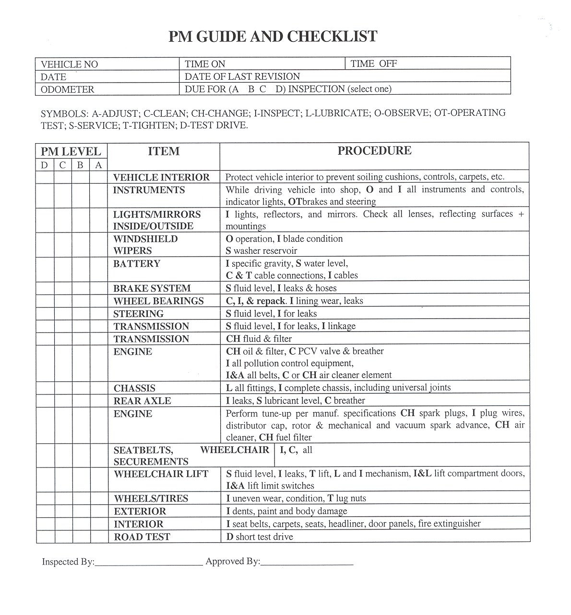

Appendix D – Transit Bus PM Inspection
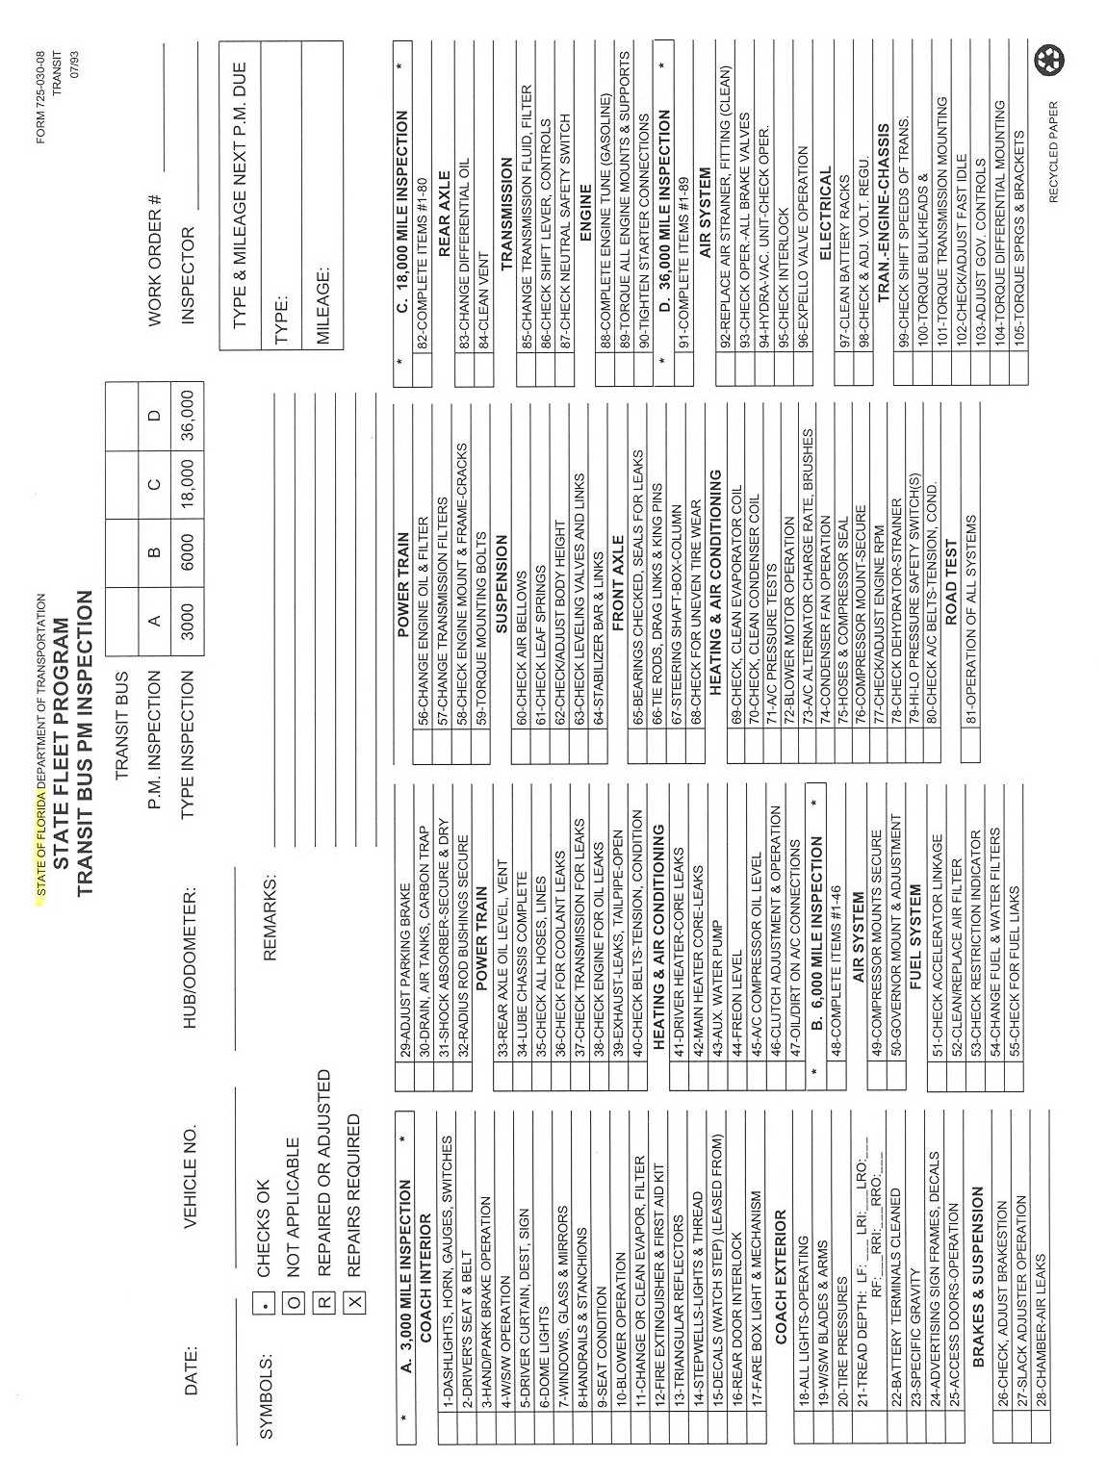
Appendix E – Preventive Maintenance and Inspection, Vans and Wagons
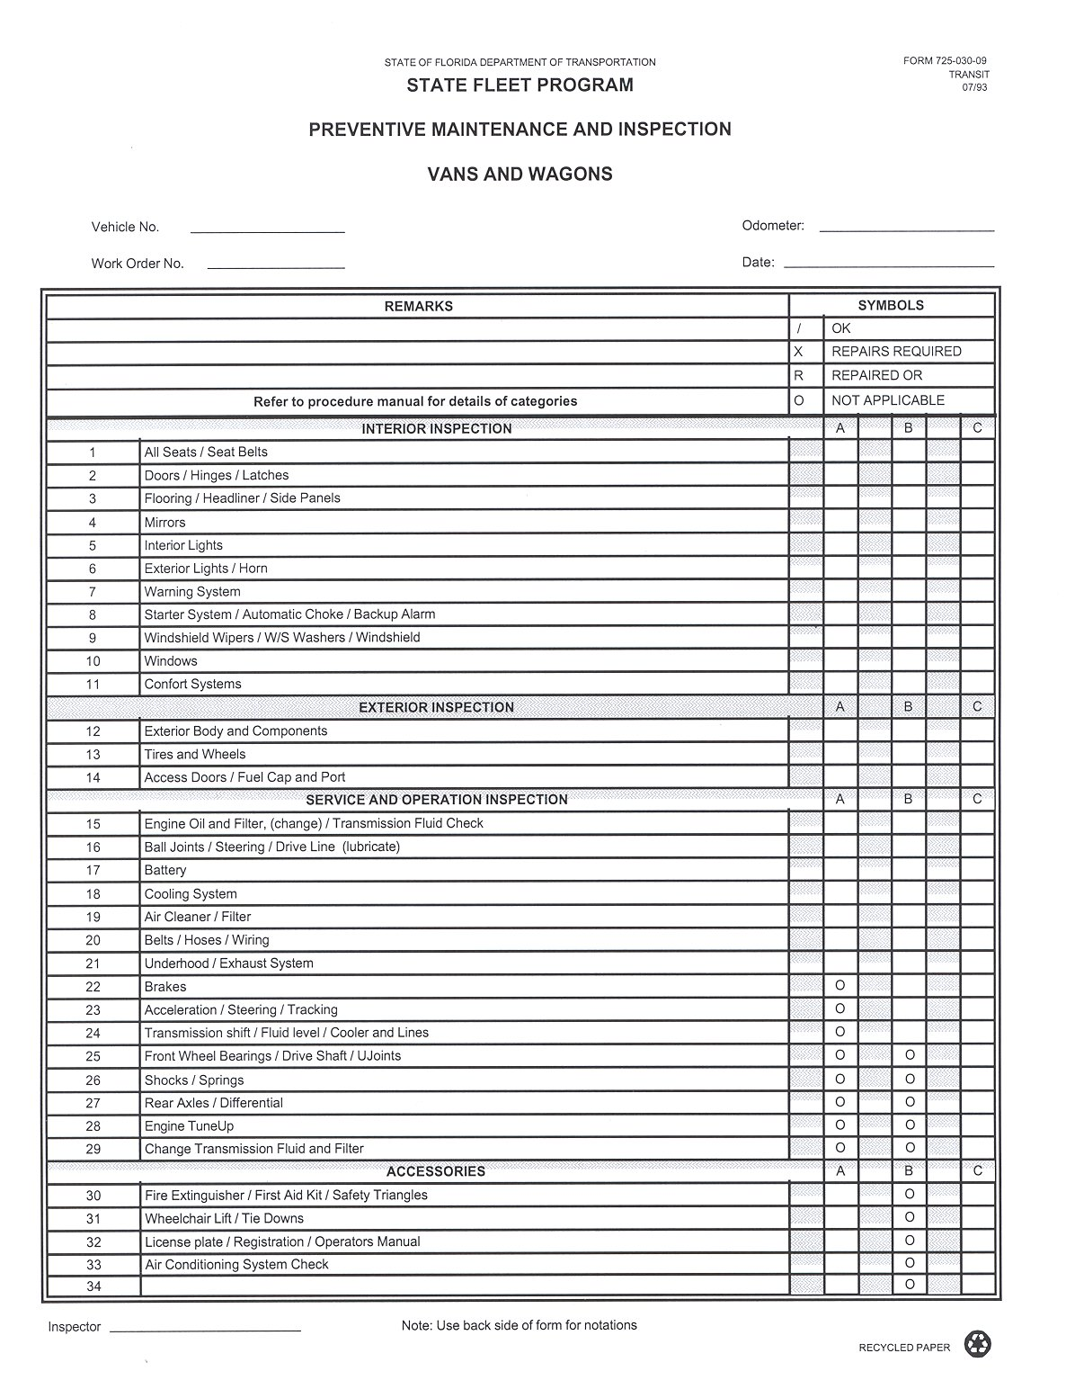

Appendix F – Operator’s Defect Report
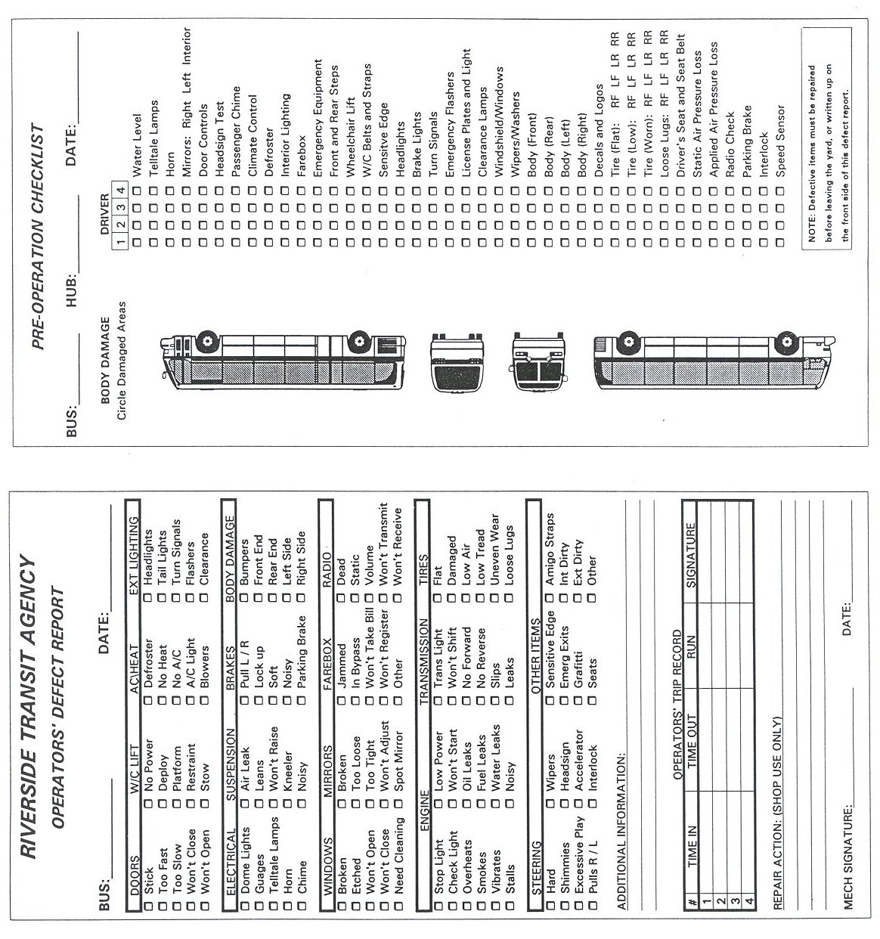

Appendix G – Pre-Trip Inspection Sheet
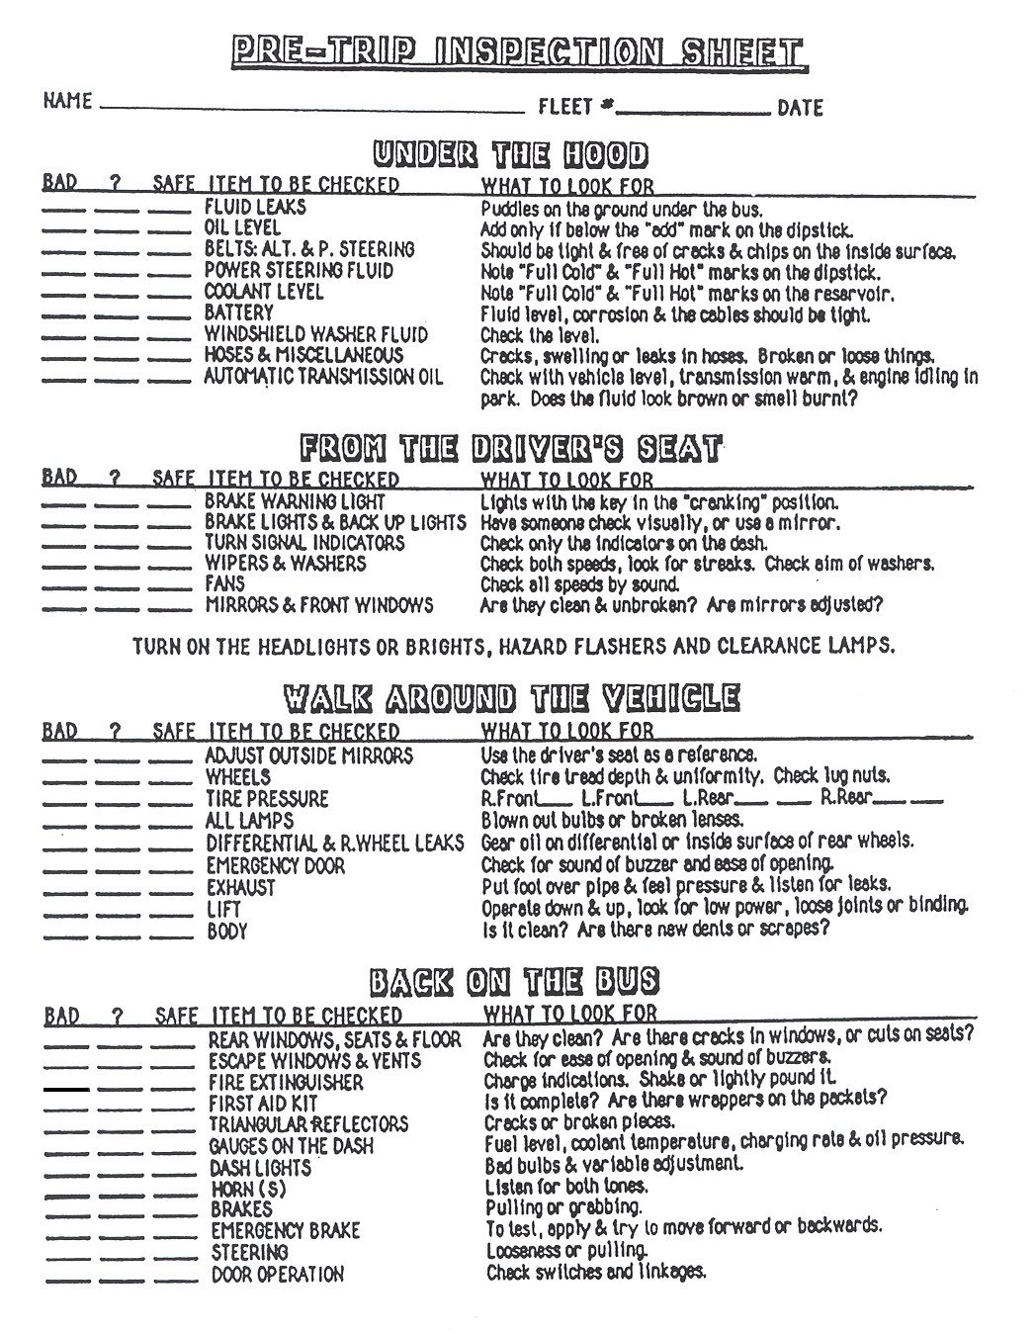

Appendix H – Vehicle Cleanliness Inspection/Task Sheet
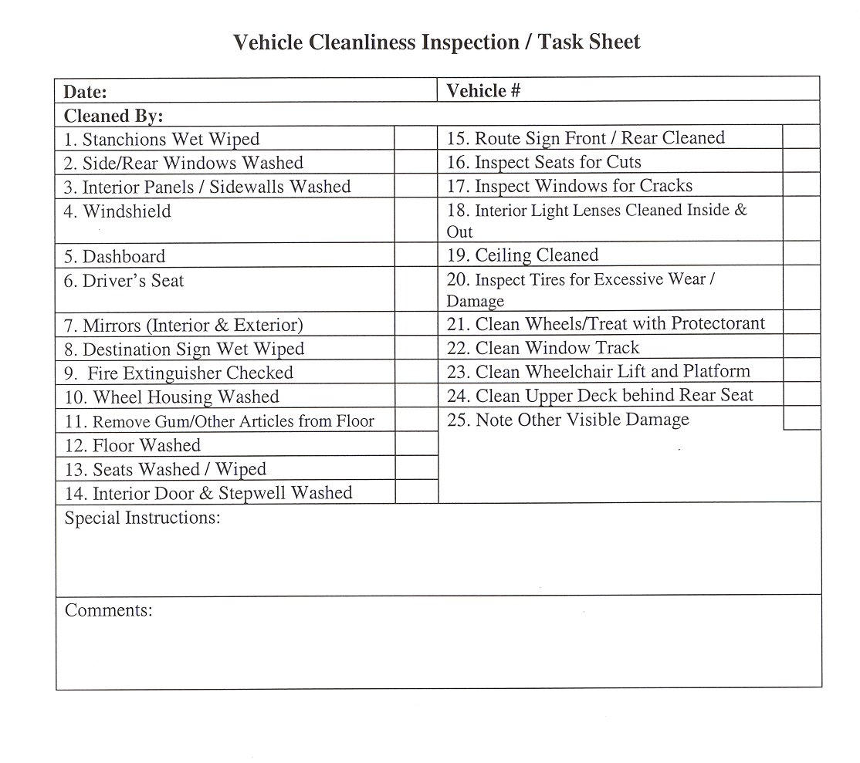

Appendix I – Transit Agency Vehicle Maintenance: Weekly Report
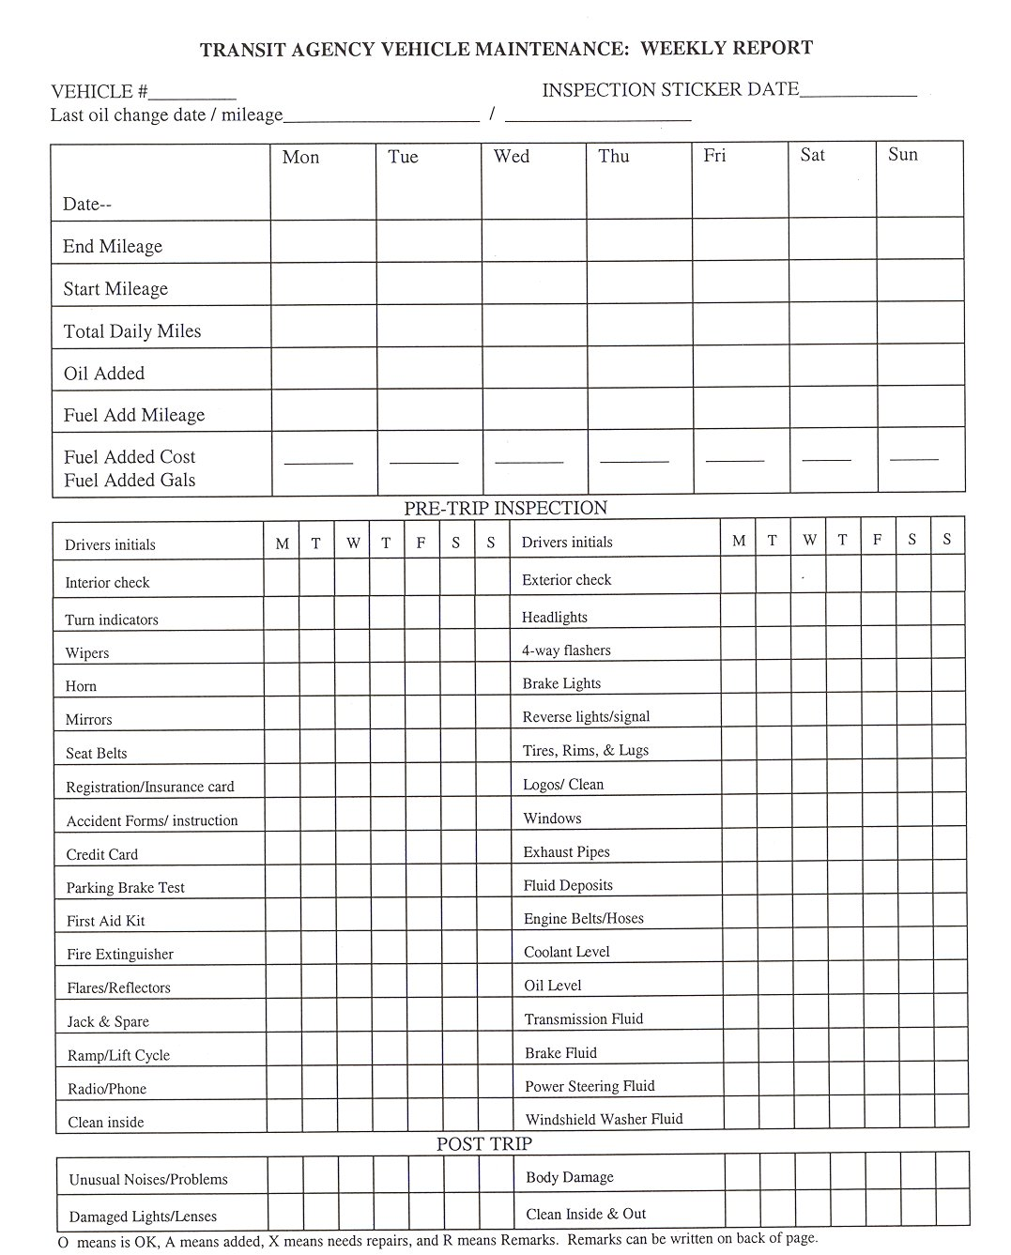

Appendix J – Bus Maintenance Work Order
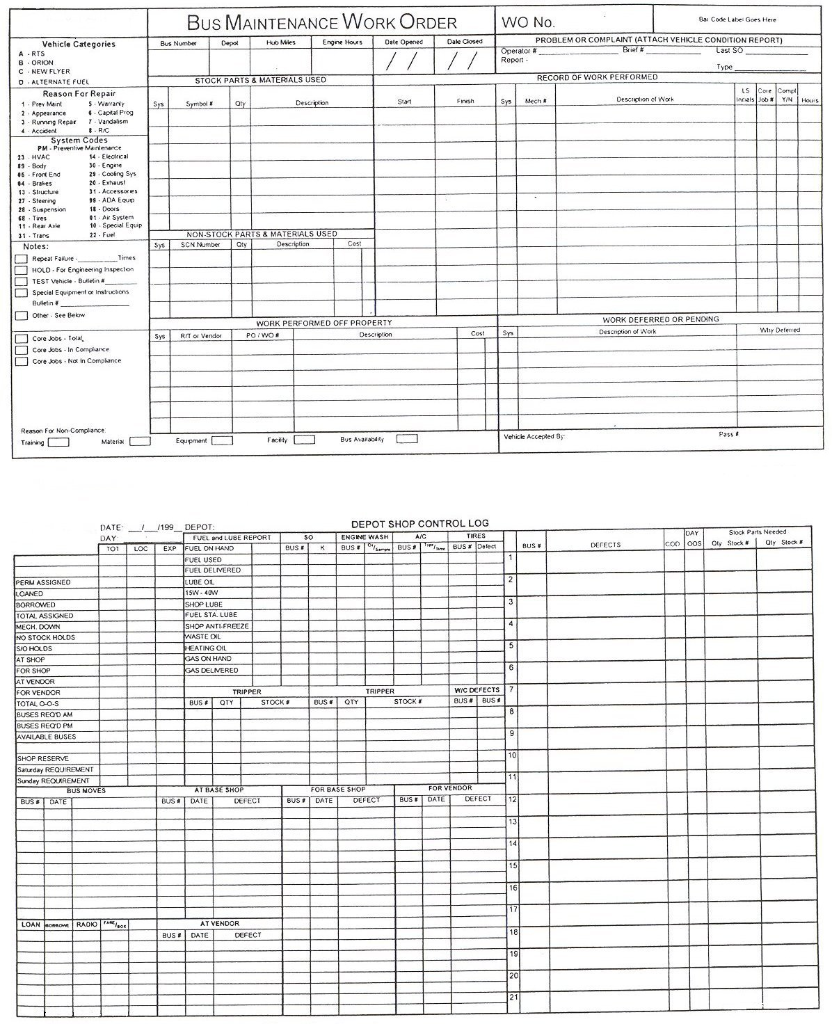

Appendix K – Equipment Inventory
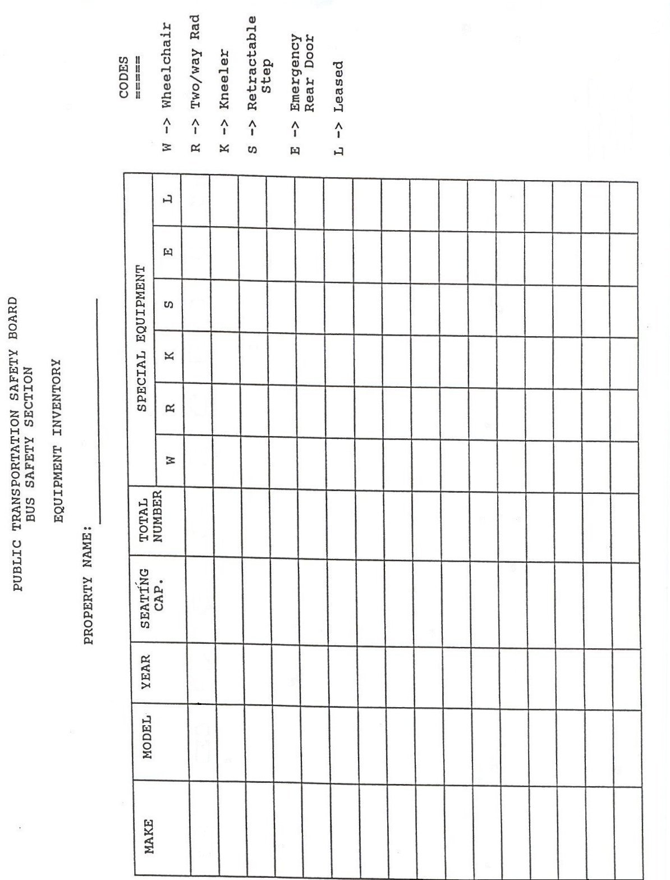

Appendix L – Vehicle Master Record
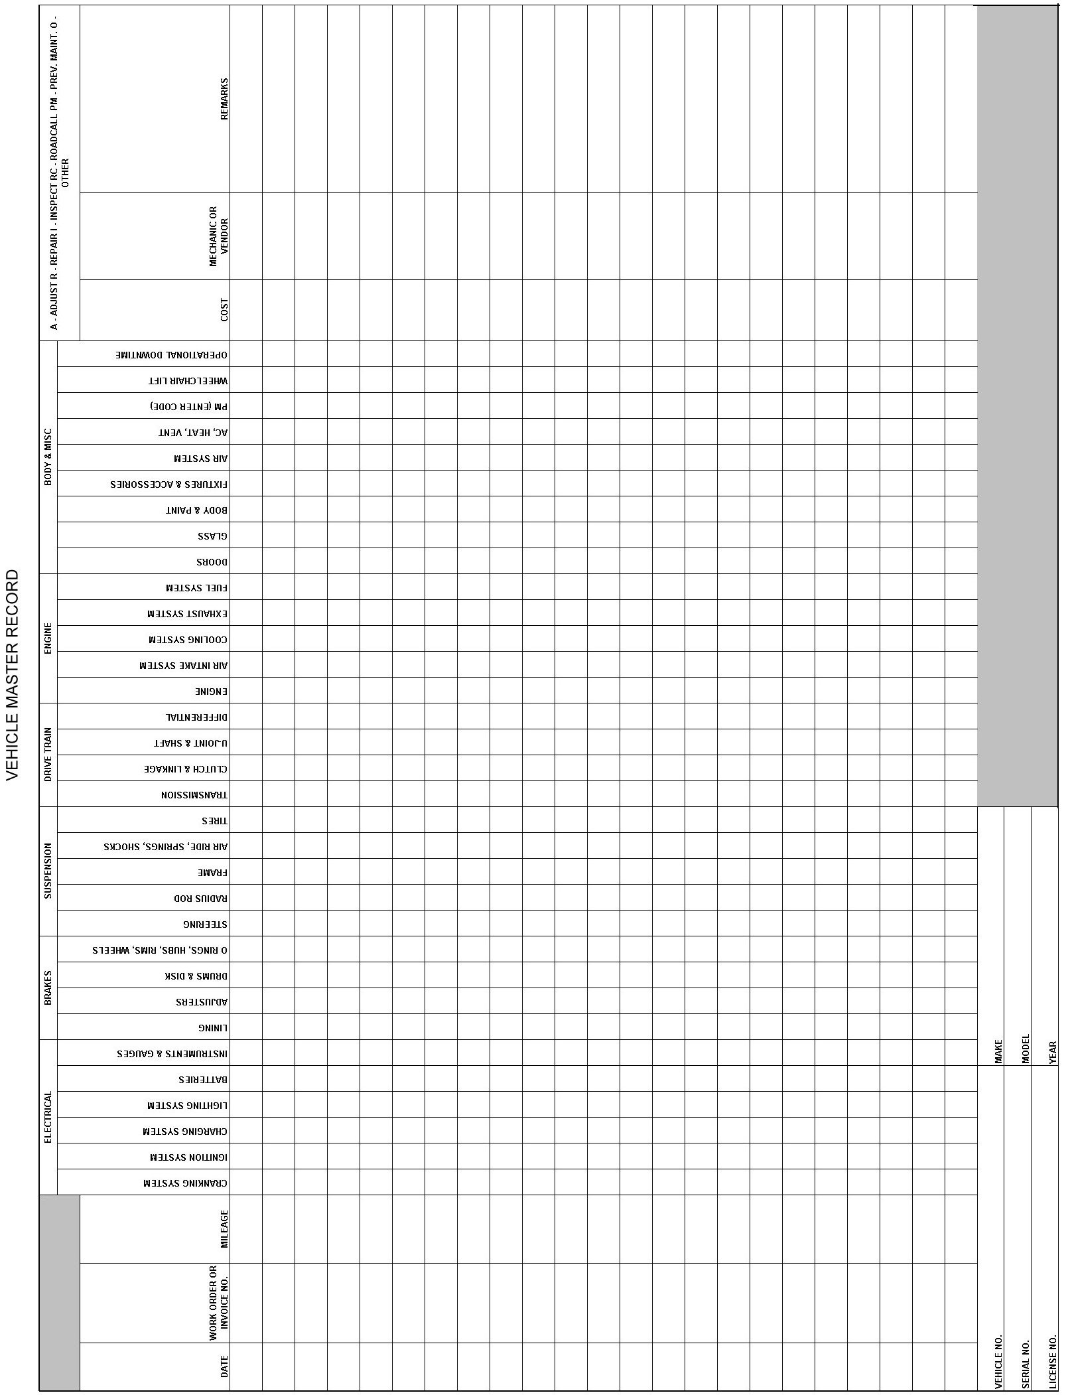

Appendix M – Vehicle Information
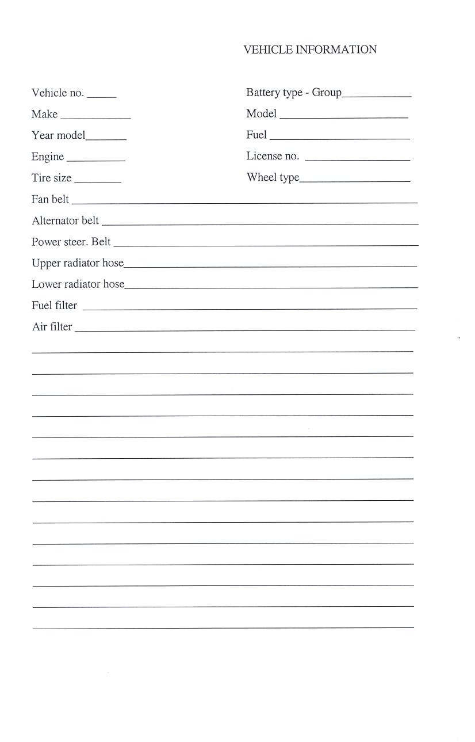

Appendix N – Facility Inspection Checklist
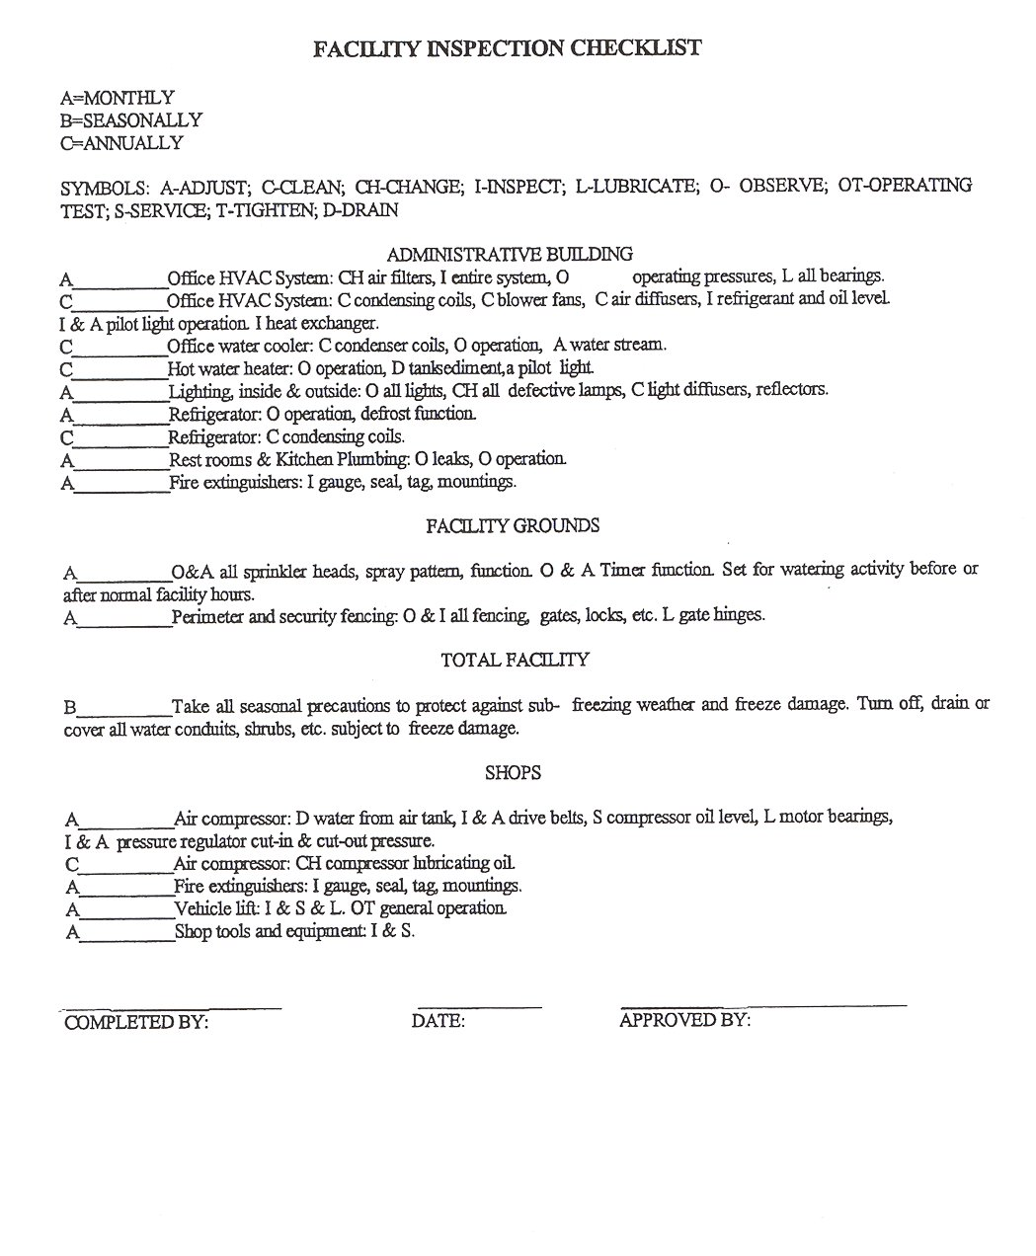

Appendix O – Warranty Claim
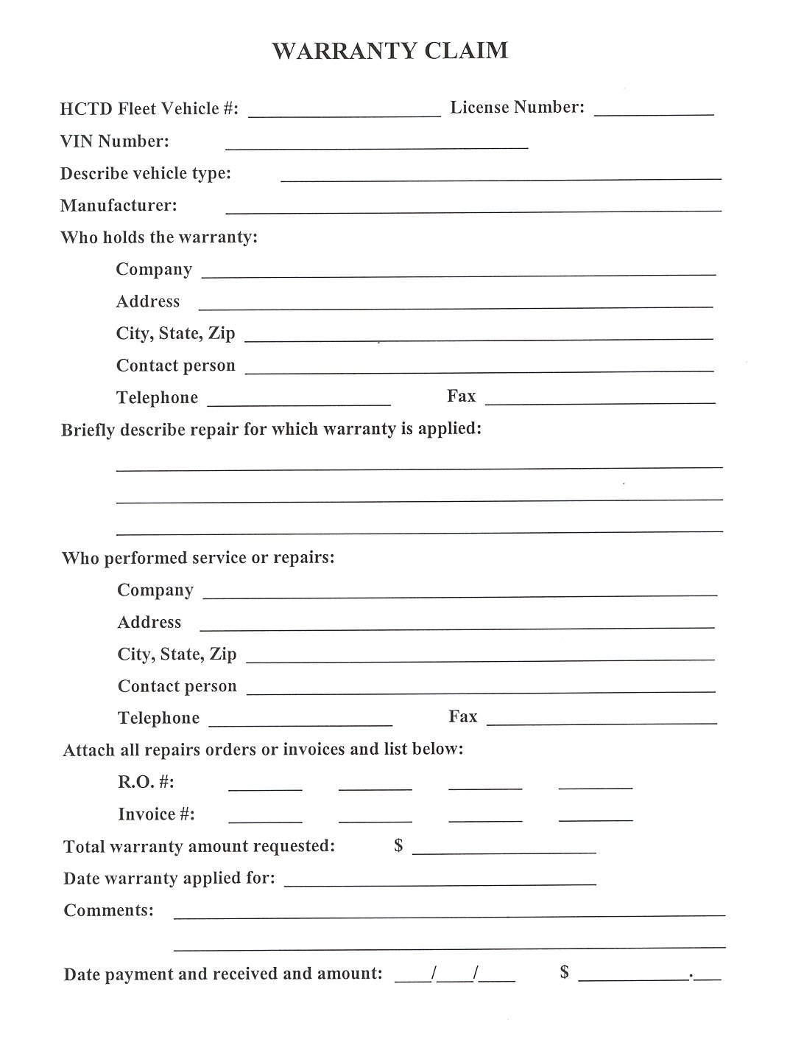
Appendix P – Warranty Claim Summary


